SIMATS ENGINEERING
ASSESSMENT TOOL 2

NAME : YuvanShankar U
REG NO : 192511265
COURSE NAME: Database Management Systems
COURSE CODE: CSA0501

COURSE OUTCOME COVERED

CO1: Analyze DBMS architecture, different data models, schema types, and design ER/EER diagrams, relational schemas for case-based scenarios by identifying entities and relationships. (BL1, BL2)

QUESTIONS Total Marks: 50
Q.N o | Question | Bloom's Level | Marks
1 | Construct a concept map linking the following terms: DBMS, Schema, Instance, Data Model, ER Diagram, Entity, Attribute, Relationship. | BL2 – Understand | 5
2 | Create a concept map for the three-level ANSI/SPARC architecture showing data independence at each level. | BL2 – Understand | 5
3 | Map the relationship between file-based systems and database systems, highlighting the problems solved by DBMS. | BL2 – Understand | 5
4 | Design a concept map for ER diagram components: entity, weak entity, attribute types, relationship types, and participation constraints. | BL2 – Understand | 5
5 | Construct a concept map comparing Hierarchical, Network, and Relational data models with their key properties. | BL2 – Understand | 5
6 | Develop a concept map for the EER model showing how it extends the basic ER model with generalization, specialization, and aggregation. | BL2 – Understand | 5
7 | Create a visual concept map for the DBMS software architecture, illustrating the flow from user request to data retrieval. | BL2 – Understand | 5
8 | Map the data models discussed in CO1 to real-world applications and explain the suitability of each model. | BL2 – Understand | 5
9 | Construct a concept map for schemas and instances, showing how they relate to physical and logical data independence. | BL2 – Understand | 5
10 | Design a concept map for the roles and responsibilities in a DBMS environment: DBA, End User, Application Developer. | BL1 – Remember | 5

Code of Conduct:

I ____YuvanShankar U(192511265)________________ (Name / Reg No) certify that this submission is my original work and that I have adhered to the guidelines specified for this assessment. I understand that any violation of academic integrity rules will result in disciplinary action.

RUBRICS FOR CALCULATION:

Criteria | Weightage | Level 4 (Exemplary) | Level 3 (Proficient) | Level 2 (Developing) | Level 1 (Beginning)
Concept  Identification | 25% | Identifies all key concepts from literature  accurately and  comprehensivel  y | Identifies most key concepts  with minor omissions | Identifies limited  concepts; some are  irrelevant or missing | Fails to identify essential concepts
Linkages | 25% | Establishes clear,  meaningful, and accurate  relationships between concepts | Shows correct  relationships  with minor gaps | Relationships are weak,  unclear, or partially incorrect | No meaningful relationships established
Organization | 20% | Concepts are well-structured hierarchically  with logical flow and grouping | Mostly organized  with minor  structural issues | Some  organization but lacks clear hierarchy | No logical organization or structure
Integration of Literature | 20% | Integrates multiple studies effectively to show  connections and comparisons | Shows some integration of literature | Limited integration; mostly  isolated concepts | No integration of literature evidence
Clarity | 10% | Concept map is clear, neat, visually  structured, and easy to interpret | Generally clear with minor  readability issues | Clarity is reduced;  difficult to  interpret in parts | Poorly presented and hard to understand

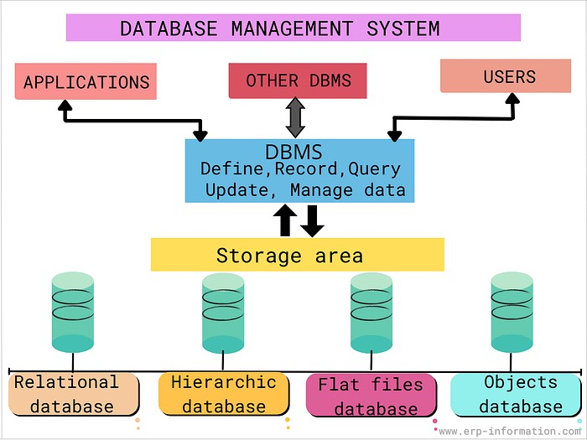

Question 1

Definitions
DBMS (Database Management System): software that defines, creates, maintains, and controls access to a database, sitting between users/applications and the physical data.
Data Model: a set of concepts and notations used to describe the structure of data — how data is organized, related, and constrained (e.g. relational model, ER model).
ER Diagram: a diagrammatic data model used at the design stage that expresses a database's structure using entities, attributes, and relationships.
Entity: a real-world object or concept about which data is stored, e.g. Student, Course.
Attribute: a property or characteristic of an entity, e.g. Name, Roll Number for the entity Student.
Relationship: an association between two or more entities, e.g. a Student ‘enrolls in’ a Course.
Schema: the overall logical design/blueprint of the database — defined once and rarely changed.
Instance: the actual data stored in the database at a particular moment in time; it changes frequently as data is inserted, updated, or deleted.

Concept map
- DBMS
  - manages → Data Model (rules for organizing data)
    - realized through → ER Diagram (visual data model used for design)
    - contains → Entity (real-world object, e.g. Student)
    - has → Attribute (property, e.g. Name, Roll No.)
    - contains → Relationship (association, e.g. ‘enrolls in’)
  - described by → Schema (logical structure, defined once)
    - populated by → Instance (actual data at a given moment, changes often)

Diagram
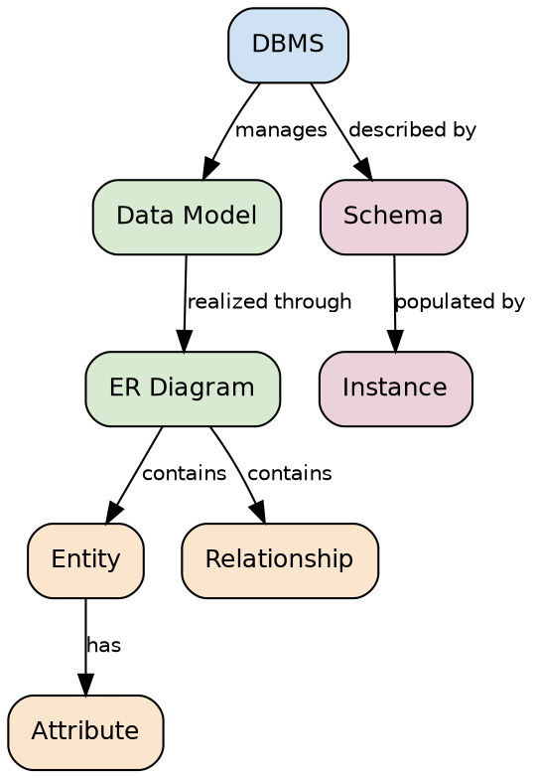

Question 2

Definitions
ANSI/SPARC Architecture: a three-level framework (external, conceptual, internal) proposed to separate user views of data from the physical storage of data.
External Level: the highest level; describes the part of the database relevant to a particular user or application (user views).
Conceptual Level: the community/global view of the entire database, describing all entities, attributes, relationships, and constraints, independent of physical storage.
Internal Level: the lowest level; describes how data is physically stored — files, indexes, storage structures.
Logical Data Independence: the ability to change the conceptual schema without changing external schemas/user views.
Physical Data Independence: the ability to change the internal (storage) schema without changing the conceptual schema.

Concept map
- External Level — user views, per-user perspective (e.g. a fee-payment screen)
  - protected from below by → Logical Data Independence
- Conceptual Level — community view of all entities/relationships (e.g. full university ER schema)
  - protected from below by → Physical Data Independence
- Internal Level — physical storage, files, indexes (e.g. B-tree index on roll number)

Diagram
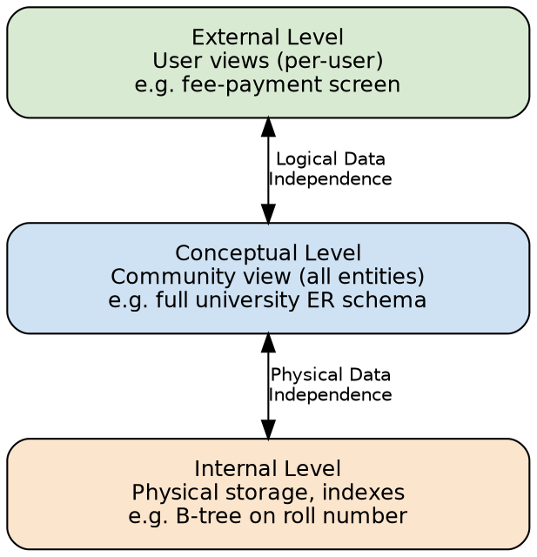

Question 3

Definitions
File-based System: an older approach where each application maintains its own separate data files, with no central control over data.
Data Redundancy: the same data is duplicated across multiple files.
Data Inconsistency: duplicate copies of data go out of sync with each other.
Data Isolation: data is scattered across files in different, incompatible formats, making it hard to combine.
Integrity Problems: consistency constraints must be coded separately into every application program.
Atomicity Problem: a system crash mid-update can leave data in a partially updated, inconsistent state.
Concurrent-Access Anomalies: simultaneous updates by multiple users/programs interfere with each other.
Security Problems: it is difficult to enforce access restrictions at the level of individual data items.

Concept map / comparison table
Problem in file-based systems | How DBMS solves it
Data redundancy | Centralized, shared data store
Data inconsistency | Single copy of data updated once
Difficulty accessing data | Query language / SQL
Data isolation | Unified schema across the organization
Integrity problems | Constraints defined once in the schema
Atomicity problems | Transaction management (ACID)
Concurrent-access anomalies | Concurrency control (locking, isolation)
Security problems | Authorization and access-control mechanisms

Diagram
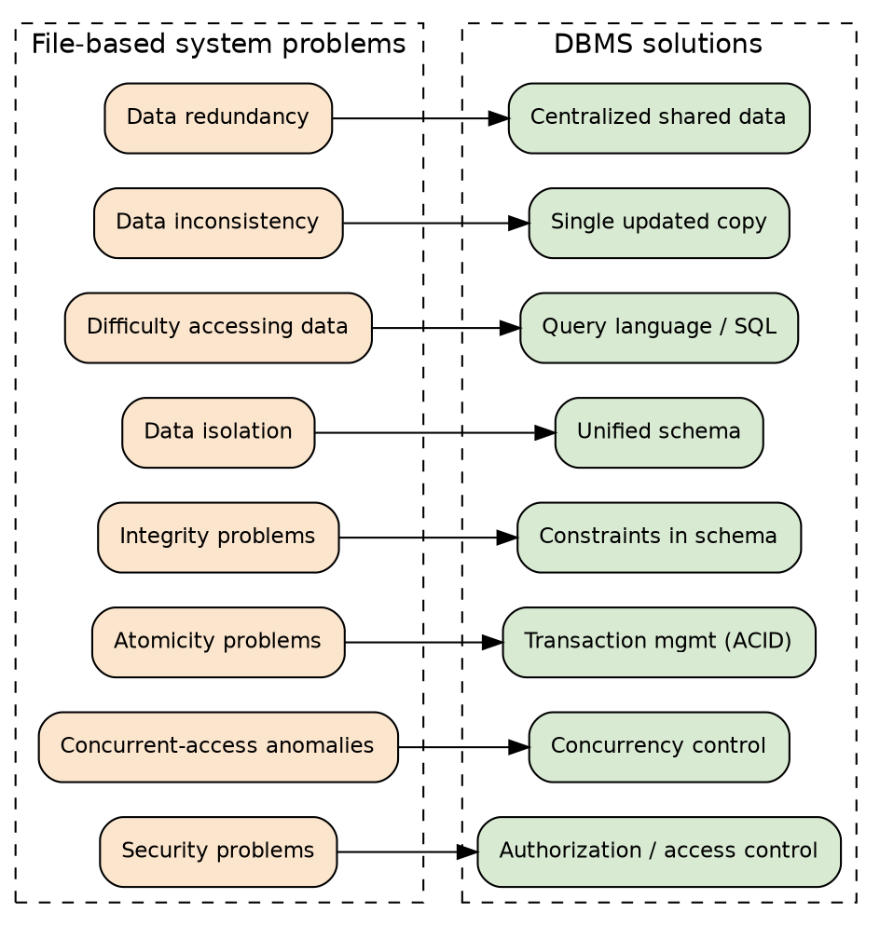

Question 4

Definitions
Strong Entity: an entity that has its own primary key and does not depend on any other entity for its existence, e.g. Student.
Weak Entity: an entity that cannot be uniquely identified by its own attributes alone and depends on an owner (strong) entity, using a partial key, e.g. Dependent of an Employee.
Simple Attribute: an atomic attribute that cannot be divided further, e.g. Age.
Composite Attribute: an attribute that can be divided into smaller sub-parts, e.g. Address into Street, City, Pin code.
Single-valued Attribute: an attribute that holds only one value per entity, e.g. Date of Birth.
Multi-valued Attribute: an attribute that can hold multiple values, e.g. a person’s set of Phone Numbers.
Derived Attribute: an attribute whose value is computed from another attribute, e.g. Age derived from Date of Birth.
One-to-One (1:1) Relationship: one instance of an entity relates to exactly one instance of another.
One-to-Many (1:N) Relationship: one instance of an entity relates to many instances of another.
Many-to-Many (M:N) Relationship: many instances of one entity relate to many instances of another.
Total Participation: every instance of an entity must participate in the relationship (mandatory).
Partial Participation: instances of an entity may or may not participate in the relationship (optional).

Concept map
- ER Diagram Components
  - Entity
    - Strong Entity — has its own primary key (e.g. Student)
    - Weak Entity — depends on owner entity, uses partial key (e.g. Dependent)
  - Attribute Types
    - Simple / Composite
    - Single-valued / Multi-valued
    - Derived
  - Relationship Types
    - One-to-One (1:1)
    - One-to-Many (1:N)
    - Many-to-Many (M:N)
  - Participation Constraints
    - Total (mandatory)
    - Partial (optional)

Diagram
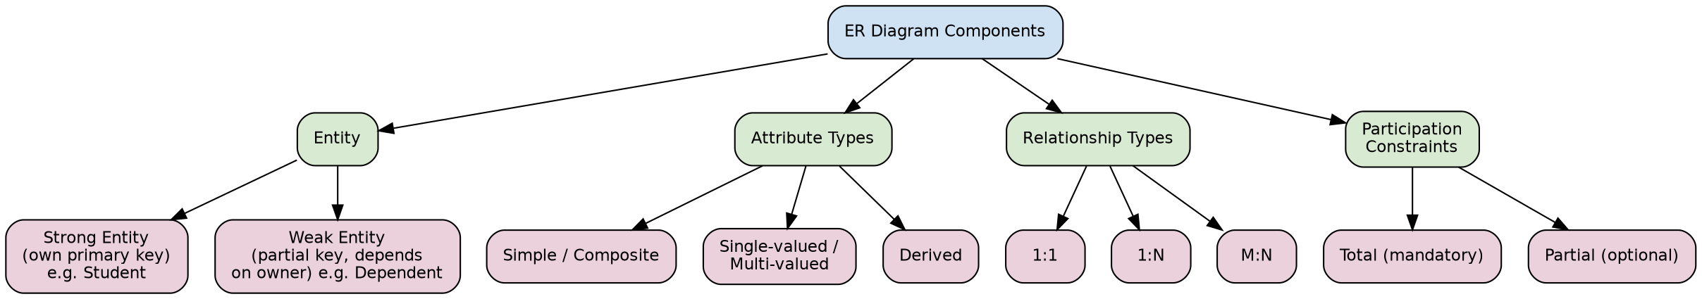

Question 5

Definitions
Hierarchical Model: organizes data in a tree-like structure where each child record has exactly one parent (1:N relationships only).
Network Model: organizes data as a graph, allowing a record to have multiple parents, supporting many-to-many relationships via pointers.
Relational Model: organizes data into tables (relations) of rows and columns, linked using keys, and manipulated using a declarative query language (SQL).

Concept map / comparison table
Property | Hierarchical | Network | Relational
Structure | Tree (parent–child) | Graph (multiple parents) | Tables (rows/columns)
Relationship support | 1:N only | M:N supported | 1:1, 1:N, M:N via keys
Navigation | Top-down traversal | Pointer-based traversal | Declarative (SQL)
Flexibility | Rigid | Complex but flexible | High, set-based
Example system | IMS | IDMS | MySQL, Oracle, PostgreSQL

Diagram
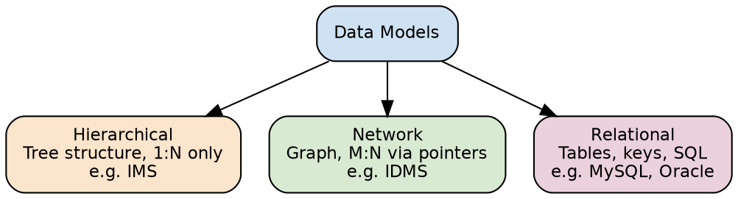

Question 6

Definitions
EER (Enhanced Entity-Relationship) Model: an extension of the basic ER model that adds concepts such as generalization, specialization, and aggregation to model complex applications more accurately.
Generalization: a bottom-up process that combines several lower-level entities sharing common features into one higher-level (generalized) entity, e.g. Car and Truck generalized into Vehicle.
Specialization: a top-down process that divides a higher-level entity into distinct lower-level sub-entities based on distinguishing characteristics, e.g. Employee specialized into Manager and Engineer.
Disjoint Constraint: an entity instance can belong to only one specialized sub-class, not more than one.
Overlapping Constraint: an entity instance may belong to more than one specialized sub-class simultaneously.
Total Specialization: every instance of the higher-level entity must belong to at least one sub-class.
Partial Specialization: instances of the higher-level entity are not required to belong to any sub-class.
Aggregation: a concept where a relationship set itself is treated as a higher-level entity so it can participate in another relationship, e.g. the relationship ‘Works-on’ (Employee–Project) participating in ‘Manages’.

Concept map
- ER Model (base)
  - extended by → EER Model
    - Generalization — bottom-up, combines entities (e.g. Car + Truck → Vehicle)
    - Specialization — top-down, splits entity (e.g. Employee → Manager, Engineer)
    - constraint: Disjoint vs Overlapping
    - constraint: Total vs Partial
    - Aggregation — relationship treated as a participant in another relationship

Diagram
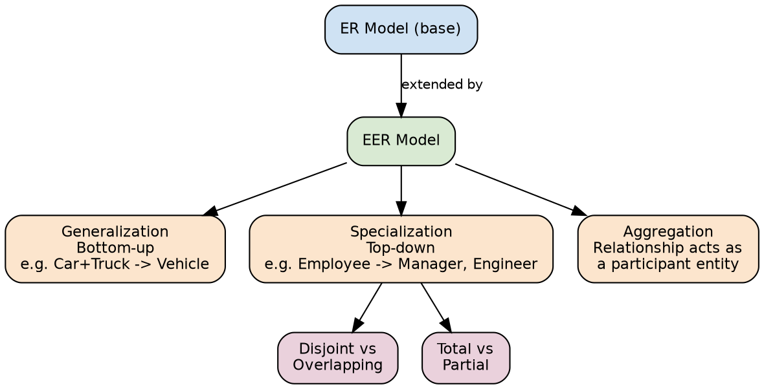

Question 7

Definitions
Query Processor: the DBMS component that parses an SQL query, checks it, and generates an optimized execution plan.
Transaction Manager: ensures that all database transactions maintain ACID properties (Atomicity, Consistency, Isolation, Durability) and manages concurrency control.
Storage Manager: manages buffers, files, and indexes, translating logical requests for data into physical read/write operations on disk.
Physical Database: the actual data files, indexes, and logs stored on secondary storage (disk).

Concept map (flow)
- User / Application submits an SQL query
- ↓
- Query Processor — parses and optimizes the query
- ↓
- Transaction Manager — ensures ACID properties, handles concurrency
- ↓
- Storage Manager — manages buffers, files, and indexes
- ↓
- Physical Database — data actually read from/written to disk
- ↓
- Result set returned back up the chain to the User

Diagram
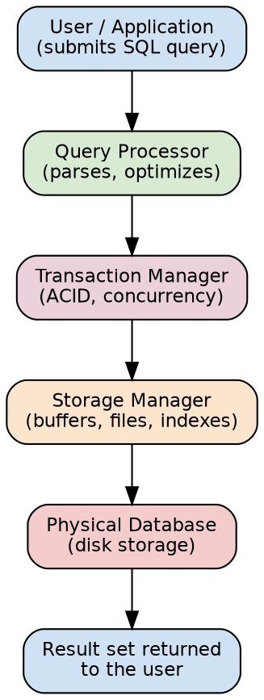

Question 8

Definitions
Object-Oriented Data Model: represents data as objects (combining data and behaviour/methods), similar to object-oriented programming, suited to complex data types.

Concept map / suitability table
Data model | Real-world application | Why it fits
Relational | Banking, ERP, e-commerce | Strong consistency, structured tabular data, mature SQL tooling
Hierarchical | File systems, XML documents, org charts | Natural single-parent hierarchy
Network | Airline reservation, telecom routing | Complex many-to-many relationships
Object-oriented | CAD/CAM, multimedia, engineering design | Stores complex objects with embedded behaviour

Diagram
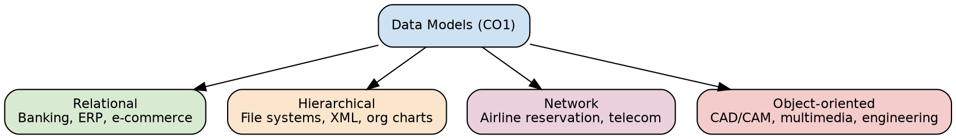

Question 9

Definitions
Physical Schema: the design describing how data is stored physically — file organization, storage structures, and indexes.
Logical (Conceptual) Schema: the design describing the logical structure of the whole database — tables, attributes, and constraints — independent of physical storage.

Concept map
- Database
  - Schema (design-time, rarely changes)
    - Physical Schema — storage structures, file organization, indexes
    - protected by → Physical Data Independence
    - Logical / Conceptual Schema — tables, attributes, constraints
    - protected by → Logical Data Independence
  - Instance (run-time, changes constantly)
    - = actual data snapshot at a given moment, validated against the Schema

Diagram
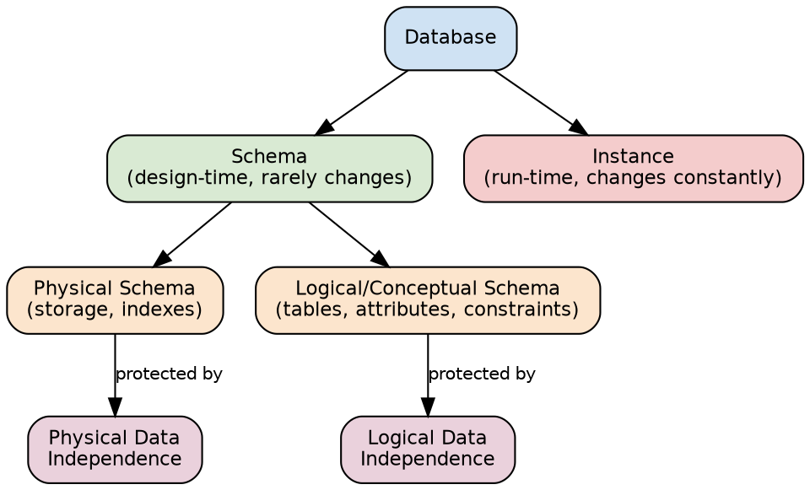

Question 10

Definitions
Database Administrator (DBA): the person responsible for the overall design, control, security, and maintenance of the database.
Application Developer: a professional who writes programs (using DML, embedded SQL, or APIs) and builds forms/reports that interact with the database.
End User: a person who ultimately queries, updates, and generates reports from the database.
Naive User: an end user who interacts with the database only through pre-built application forms/menus, e.g. an ATM user.
Casual User: an end user who occasionally accesses the database using ad-hoc queries.
Sophisticated User: an end user, such as an analyst, who writes their own queries and reports directly.

Concept map
- Database Administrator (DBA)
  - Authorizes access and grants privileges
  - Defines schema and storage structure
  - Monitors performance, backup, and recovery
  - → provides schema/platform to → Application Developer
    - Writes programs using DML (embedded SQL, APIs)
    - Builds forms, reports, and application logic
  - → builds applications used by → End User
    - Naive user — uses pre-built forms/apps (e.g. ATM user)
    - Casual user — occasional ad-hoc queries
    - Sophisticated user — writes own queries/reports (analysts)

Diagram
